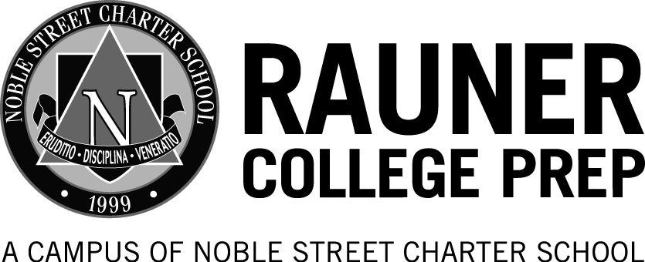
Rauner College Prep Blogging Policy and Contract
This is a set of general guidelines for the use of weblogs (“blogs”) at Rauner College Prep. Blogs are considered an extension of the classroom and therefore are subject to these guidelines as well as the rules and regulations of Rauner College Prep and the Noble Charter School Network. The use of school computers is limited to assigned schoolwork; personal blogs that do not pertain to classwork at Rauner College Prep should not be accessed from school computers. These guidelines are not meant to be exhaustive and do not cover every contingency. If you are ever in doubt about the appropriateness of an item - ask a parent or teacher.
Safe and Responsible Blogging
The most basic guideline to remember when blogging is that the blog is an extension of your classroom. You should not write anything on a blog that you would not say or write in your classroom. Use common sense, but if you are ever in doubt ask a teacher or parent whether or not what you are considering posting is appropriate. If you are going to err, err on the safe side. Here are some specific items to consider:
- The use of blogs is considered an extension of your classroom. Therefore, any speech that is considered inappropriate in the classroom is inappropriate on a blog. This includes, but is not limited to, profanity; racist, sexist or discriminatory remarks; personal attacks.
- Blogs are used primarily as learning tools, either as extensions of conversations and thinking outside of regular class time, or as the basis for beginning new classroom discussions. Either way, be sure to follow all rules and suggestions that are offered by your teachers regarding appropriate posting in your class.
- Blogs are about ideas – therefore, agree or disagree with the idea, not the person. Freedom of speech does not give you the right to be uncivil. Use constructive criticism and use evidence to support your position. Read others’ posts carefully – often in the heat of the moment you may think that a person is saying one thing, when really they are not.
- Blogs are public. Whatever you post on a blog can be read by anyone and everyone on the Internet. Even if you delete a post or comment, it has often already been archived elsewhere on the web. Do not post anything that you wouldn’t want your parents, your best friend, your worst enemy, or a future employer to read.
- Blog safely. NEVER post personal information on the web (including, but not limited to, last names, personal details including address or phone numbers, or photographs). (Note: The advice to not use your last name is for your protection. Teachers may choose to use their last names for their posts/comments.) Do not, under any circumstances, agree to meet someone you have met over the Internet.

In order to blog at Rauner College Prep, I agree to the following statements:
- I will not use any curse words or inappropriate language.
- I will not use fighting words or provoke anyone.
- I will avoid the use of chat language.
- I will try to spell everything correctly.
- I will only give constructive criticism.
- I will only use my first name, and those of my classmates.
- I will not plagiarize.
- I will only post on the topic of an assignment or in response to another student’s post.

I recognize that breaking any of these rules could lead to any of the following consequences depending on severity and repetition:
- warning
- deletion of some or all of the post
- temporary loss of blogging privileges
- DT and suspension
- permanent loss of blogging privileges

I further recognize that Rauner College Prep blogs are considered a virtual extension of our classrooms, and therefore all school and Noble Network Charter School rules apply. I am aware that violation of any of these rules may be referred to the School Administration.

_______________________________________
Student Name Printed

_______________________________________
Student Signature

________________________________________
Date

