Name: Block:

APUSH Chapter 3: The Southern Colonies in the 17th Century Review

Identification: Define the key terms below. Write all that you know.
Indentured Servants

Joint Stock

Virginia Company – motive/characteristics

Bacon’s Rebellion

Headright System

Tobacco

Development of Slavery

What are the Similarities & Differences between Native Americans & English Settlers?
Native Americans | Both | English Settlers
Comprehension and Analysis: Answer the questions below.
- Tobacco dominated European settlement in the seventeenth-century Chesapeake. How did tobacco agriculture shape the region’s development? In your answer, be sure to address the demographic and geographic features of the colony.
- Why had slave labor largely displaced indentured servant labor by 1700 in Chesapeake tobacco production?
- Bacon’s Rebellion highlighted significant tensions within Chesapeake society. What provoked the rebellion, and what did it accomplish? In your answer, be sure to consider causes and results in the colonies and in England.

Map Activity: Use the map below to help you answer the questions.
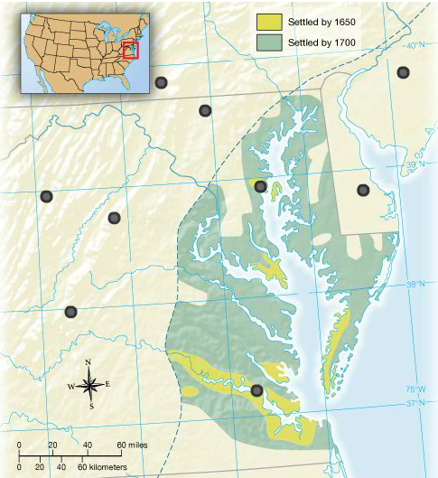
- What physical features correspond to the earliest habitation by English settlers?

- Why was access to navigable water so important? Given the settlers’ need for defense against native tribes, what explains the distance between settlements?

